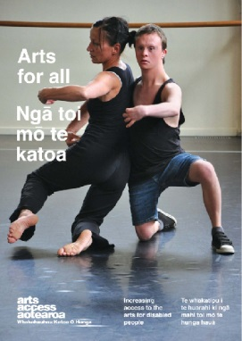
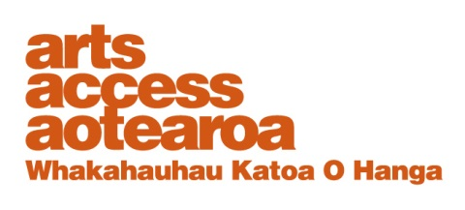
CASE STUDY: Arts For All

City Gallery Wellington: Kirsty Glengarry, Manager Education and Public Programmes City Gallery Wellington
Arts For All is an Arts Access
Aotearoa/Creative
New Zealand partnership programme. The aim of this programme is to encourage arts
organisations, venues and producers to improve their
access to disabled audiences.
Download Arts For All, published in 2014 by Arts Access Aotearoa, at artsaccess.org.nz
or call 04 802 4349 for a hard copy.
For the full picture about arts and accessibility in New Zealand, you can download Arts For All | Ngā toi mo te katoa, published by Arts Access Aotearoa, 2014.

For the full picture about arts and accessibility in New Zealand, you can download Arts For All | Ngā toi mo te katoa, published by Arts Access Aotearoa, 2014.

For the full picture about arts and accessibility in New Zealand, you can download Arts For All | Ngā toi mo te katoa, published by Arts Access Aotearoa, 2014.

May 2010

1. Background: about us

City Gallery Wellington is a contemporary art gallery in central Wellington. Without an art collection of its own, the gallery has changing exhibitions that showcase the best international, national and local contemporary art available.

City Gallery offers visitors the chance to experience contemporary creative ideas and to gain a new insight or perspective on the world in which we live.

I manage Education and Public Programmes, overseeing the Gallery's educators who provide curriculum-linked programmes to primary and secondary school children. I am responsible for developing and delivering programmes for the wider community.

Key examples of these education programmes are tours for Deaf people conducted by Deaf people; workshops for visually impaired people; and Gallery Babes.

Developing and delivering public programmes such as artist and curator talks, lectures, late-night music events, dance programmes, panel discussions and film screenings are also an important part of my role.

2. What access means to City Gallery Wellington

Staff at City Gallery Wellington are interested in providing access to all communities through excellent art programming and good physical access.

An important strategy for building audiences across communities is to create the best contemporary art exhibition programme available and a
complementary range of public events and education programmes that extend understanding about the artwork on display.

Providing meaningful ways for various communities to access and engage with art on display is a key part of my role. This access is provided through targeted tours and programmes: e.g. those designed with and for the Deaf and visually impaired communities.

3. Our journey: the barriers, challenges and rewards

I was inspired when working with Marie Baltusova, who majored in teaching art to the visually impaired and developed programmes for this community in galleries in Finland and the Czech Republic. Marie devised workshops at Auckland Art Gallery Toi o Tāmaki featuring a tour, art making and tactile diagrams. These programmes are planned to continue when the Main Gallery re-opens next year.

This experience inspired me to pilot Deaf tours led by Deaf people at City Gallery. I had worked with interpreters in the past and noticed how tiring it was for them to translate my tours. It occurred to me to train Deaf guides to lead their own tours and I was able to trial this idea during the Kusama exhibition. With the assistance of Wellington City Council advisors, I found two wonderful Deaf tour guides who were informative and entertaining, and helped their groups to learn more about the exhibition in an enjoyable way.

This was a more expensive and time-intensive way to work as I employed interpreters to translate my initial discussions with the guides and the exhibition training sessions. However, it was worth the extra expense as the tours attracted good numbers, and I was able to stand back and let the community lead these events.

More tours were scheduled in April but these were not as successful. Sadly, no one attended the first session and the second tour was rescheduled to coincide with New Zealand Sign Language Week in response to a request from the Deaf Association but was then cancelled due to other planned events. I am interested in continuing this programme and am seeking feedback from the community.

I was also inspired to initiate touch workshops at City Gallery during the opening season this year. The artist Regan Gentry sourced cane from the Royal New Zealand Foundation for the Blind to construct his work, Make Way: Regan Gentry, which showed at the Gallery last year. A Braille signage panel and brochure was produced for this exhibition and a touch workshop was held for the visually impaired community to honour their involvement. We invited the community to a curator's tour and this group were the only visitors able to touch the artwork.

A discussion was held about how the visitors would like to access the gallery in the future and there was much interest in a programme for The Forty Part Motet by Janet Cardiff. This sound installation features 40 speakers, each representing a single chorister's voice. A second session was organised, where curator Heather Galbraith delivered a curator's tour with many staff assisting on the day.

4. Three top tips to becoming more accessible

Among the key learnings I have made working with various community groups to provide public programmes and education programmes in a gallery setting are:

- It is vital to build good relationships with your community of interest and to work with them to develop programmes rather than working in isolation.
- Look for programme partners who have similar aims and objectives to ensure that the project offers win/win outcomes for everyone.

